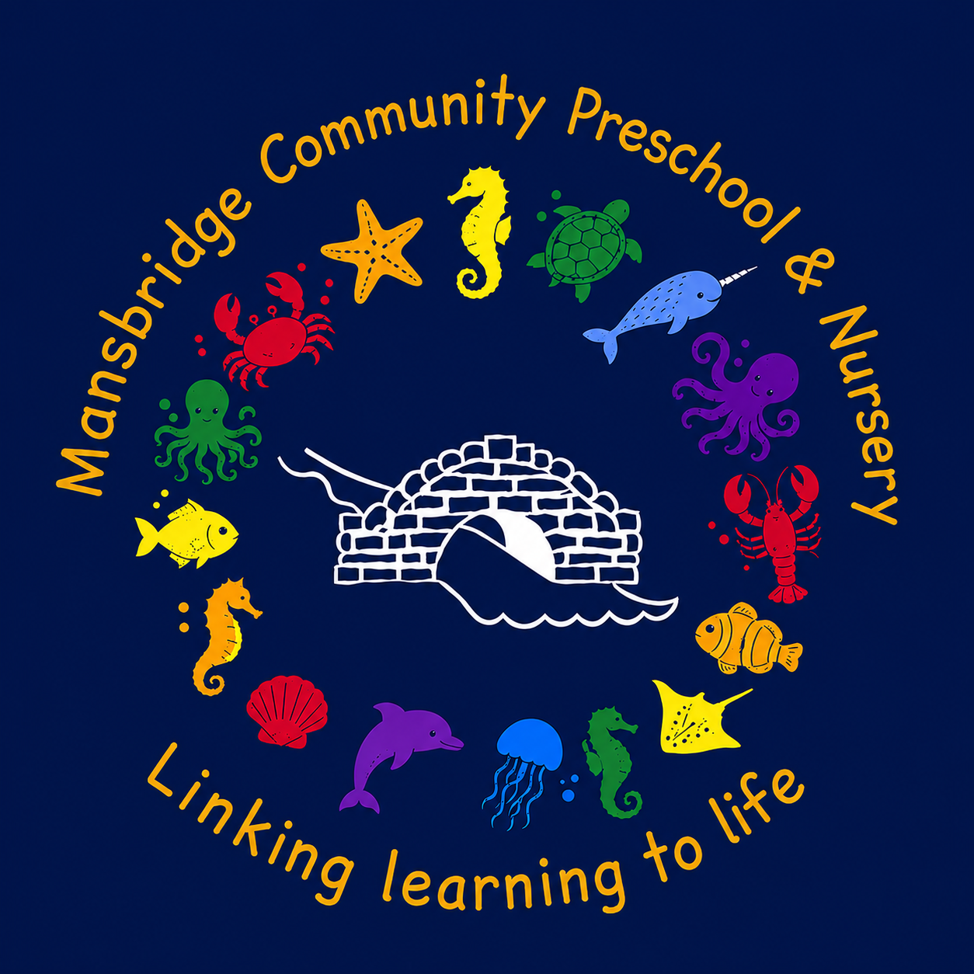
Welcome Pack

Mansbridge Community Pre-School & Nursery
Octavia Road
Mansbridge
Southampton
SO18 2LX
Registered Charity:1155811
Ofsted Registered:EY546269

02380 516525
07784 965068
info@mansbridgepreschool.co.uk
www.mansbridgepreschool.co.uk
Welcome to MCPS and thank you for registering your child with us.
We know how important your child is and aim to deliver the highest quality of care and education to help them to achieve their best by providing a safe, happy and stimulating environment in which your child will gain confidence through various play activities. We offer a planned and varied curriculum, valuing each child individually as they embark on their learning journey at Mansbridge Community Pre-School (MCPS).
This prospectus aims to provide you with an introduction to MCPS, our routines, our approach to supporting your child’s learning and development and how we aim to work together with you to best meet your child’s individual needs. This should be read alongside our setting policies, some of which are included in this pack. All policies are available on request.
Our setting aims to:
- provide high quality care and education for children below statutory school age;
- work in partnership with parents to help children to learn and develop;
- add to the life and well-being of the local community; and
- offer children and their parents a service that promotes equality and values diversity.

Every child deserves the best possible start in life and the support that enables them to fulfil their potential. Children develop quickly in the early years and a child’s experiences between birth and age five have a major impact on their future life chances.
A secure, safe and happy childhood is important in its own right. Good parenting and high quality early learning together provide the foundation children need to make the most of their abilities and talents as they grow up.

Parents
Parents are very important to us at Mansbridge Community Pre-School, you will be:
- valued and respected;
- kept informed;
- consulted;
- involved; and
- included at all levels.

*As a community based, voluntary managed setting, we also depend on the good will of parents and their involvement to keep going. Membership of the setting carries expectations on parents for their support and commitment.
Children’s development and learning
We aim to ensure that each child:
- is in a safe and stimulating environment with teaching and support from adults who respond to their individual interests and needs and help them to build their learning over time;
- is given generous care and attention, because of our ratio of qualified staff to children, as well as volunteers;
- has the chance to join with other children and adults to live, play, work and learn together;
- is helped to take forward her/his learning and development by being helped to build on what she/he already knows and can do;
- has a personal key person who makes sure each child makes satisfying progress;
- is treated as an individual;
- is resilient, capable, confident and self assured;
- is in a setting that sees parents as partners in helping each child to learn and develop; and
- is in a setting in which parents help to shape the service it offers.

Children's development and learning
The provision for children's development and learning is guided by The Early Years Foundation Stage (DfE 2024). Our provision reflects the four guiding themes and principles of the Early Years Foundation Stage.

A Unique Child
Every child is a unique child who is constantly learning and can be resilient, capable, confident and self-assured.
Positive Relationships
Children learn to be strong and independent through positive relationships.
Enabling Environments
Children learn and develop well in enabling environments, in which their experiences respond to their individual needs and there is a strong partnership between practitioners, parents and carers.

Learning and Development
Children develop and learn in different ways. the framework covers the education and care of all children in early years’ provision including children with special educational needs and disabilities.

How we provide for development and learning
The Early Years Foundation Stage (EYFS) sets the standards that all early years providers must meet to ensure that children learn and develop well and are kept healthy and safe. It promotes teaching and learning to ensure children’s ‘school readiness’ and gives children the broad range of knowledge and skills that provide the right foundation for good future progress through school and life.

The EYFS seeks to provide:
• quality and consistency in all early years settings, so that every child makes good progress and no child gets left behind
• a secure foundation through planning for the learning and development of each individual child, and assessing and reviewing what they have learned regularly
• partnership working between practitioners and with parents and/or carers
• equality of opportunity and anti-discriminatory practice, ensuring that every child is included and supported.
There are seven areas of learning and development that shape educational programmes in early years settings. All areas of learning and development are important and inter-connected.

Three areas are particularly important for building a foundation for igniting children’s curiosity and enthusiasm for learning, forming relationships and thriving.

These are the prime areas:
• Communication and language
• Physical development
• Personal, social and emotional development

Providers must also support children in four specific areas, through which the three prime areas are strengthened and applied.

The specific areas are:
• Literacy
• Mathematics
• Understanding the world
• Expressive arts and design
Children start to learn about the world around them from the moment they are born. The care and education offered by our setting helps children to continue to do this by providing all of the children with interesting activities that are appropriate for their age and stage of development.
For each area, the level of progress children should be expected to have attained by the end of the Early Years Foundation Stage (end of year R) is defined by the Early Learning Goals. These goals state what it is expected that children will know and be able to do by the end of the reception year of their education. Your child’s key person will make regular observations of your child, from these they will assess your child’s level of development and plan learning opportunities for your child to help them reach their next steps in their development.
Observations can be viewed by parents and carers via our online journal system tapestry.
Parents and carers are also encouraged to add their own observations to this.
Educational programmes must involve activities and experiences for children, as set out under each of the areas of learning;
Communication and language
The development of children’s spoken language underpins all seven areas of learning and development. Children’s back-and-forth interactions from an early age form the foundations for language and cognitive development. The number and quality of the conversations they have with adults and peers throughout the day in a language-rich environment is crucial. By commenting on what children are interested in or doing, and echoing back what they say with new vocabulary added, practitioners will build children's language effectively. Reading frequently to children, and engaging them actively in stories, non-fiction, rhymes and poems, and then providing them with extensive opportunities to use and embed new words in a range of contexts, will give children the opportunity to thrive. Through conversation, story-telling and role play, where children share their ideas with support and modelling from their teacher, and sensitive questioning that invites them to elaborate, children become comfortable using a rich range of vocabulary and language structures.
Personal, social and emotional development
Children’s personal, social and emotional development (PSED) is crucial for children to lead healthy and happy lives, and is fundamental to their cognitive development. Underpinning their personal development are the important attachments that shape their social world. Strong, warm and supportive relationships with adults enable children to learn how to understand their own feelings and those of others. Children should be supported to manage emotions, develop a positive sense of self, set themselves simple goals, have confidence in their own abilities, to persist and wait for what they want and direct attention as necessary. Through adult modelling and guidance, they will learn how to look after their bodies, including healthy eating, and manage personal needs independently. Through supported interaction with other children, they learn how to make good friendships, co-operate and resolve conflicts peaceably. These attributes will provide a secure platform from which children can achieve at school and in later life.
Physical development
Physical activity is vital in children’s all-round development, enabling them to pursue happy, healthy and active lives. Gross and fine motor experiences develop incrementally throughout early childhood, starting with sensory explorations and the development of a child’s strength, co-ordination and positional awareness through tummy time, crawling and play movement with both objects and adults. By creating games and providing opportunities for play both indoors and outdoors, adults can support children to develop their core strength, stability, balance, spatial awareness, co-ordination and agility. Gross motor skills provide the foundation for developing healthy bodies and social and emotional well-being. Fine motor control and precision helps with hand-eye co-ordination, which is later linked to early literacy. Repeated and varied opportunities to explore and play with small world activities, puzzles, arts and crafts and the practice of using small tools, with feedback and support from adults, allow children to develop proficiency, control and confidence.
Literacy
It is crucial for children to develop a life-long love of reading. Reading consists of two dimensions: language comprehension and word reading. Language comprehension (necessary for both reading and writing) starts from birth. It only develops when adults talk with children about the world around them and the books (stories and non-fiction) they read with them, and enjoy rhymes, poems and songs together. Skilled word reading, taught later, involves both the speedy working out of the pronunciation of unfamiliar printed words (decoding) and the speedy recognition of familiar printed words. Writing involves transcription (spelling and handwriting) and composition (articulating ideas and structuring them in speech, before writing).
Mathematics
Developing a strong grounding in number is essential so that all children develop the necessary building blocks to excel mathematically. Children should be able to count confidently, develop a deep understanding of the numbers to 10, the relationships between them and the patterns within those numbers. By providing frequent and varied opportunities to build and apply this understanding - such as using manipulatives, including small pebbles and tens frames for organising counting - children will develop a secure base of knowledge and vocabulary from which mastery of mathematics is built. In addition, it is important that the curriculum includes rich opportunities for children to develop their spatial reasoning skills across all areas of mathematics including shape, space and measures. It is important that children develop positive attitudes and interests in mathematics, look for patterns and relationships, spot connections, ‘have a go’, talk to adults and peers about what they notice and not be afraid to make mistakes.
Understanding the world
Understanding the world involves guiding children to make sense of their physical world and their community. The frequency and range of children’s personal experiences increases their knowledge and sense of the world around them – from visiting parks, libraries and museums to meeting important members of society such as police officers, nurses and firefighters. In addition, listening to a broad selection of stories, non-fiction, rhymes and poems will foster their understanding of our culturally, socially, technologically and ecologically diverse world. As well as building important knowledge, this extends their familiarity with words that support understanding across domains. Enriching and widening children’s vocabulary will support later reading comprehension.
Expressive arts and design
The development of children’s artistic and cultural awareness supports their imagination and creativity. It is important that children have regular opportunities to engage with the arts, enabling them to explore and play with a wide range of media and materials. The quality and variety of what children see, hear and participate in is crucial for developing their understanding, self-expression, vocabulary and ability to communicate through the arts. The frequency, repetition and depth of their experiences are fundamental to their progress in interpreting and appreciating what they hear, respond to and observe.

Our approach to learning and development and assessment

Learning through play
Play helps young children to learn and develop through doing and talking, which research has shown to be the means by which young children learn to think. Our setting provides a range of play activities which help children to make progress in each of the areas of learning and development. In some of these activities children decide how they will use the activity and, in others, an adult takes the lead in helping the children to take part in the activity.

Characteristics of effective learning
We understand that all children engage with other people and their environment through the characteristics of effective learning that are described in the Early Years Foundation Stage as:
- playing and exploring - engagement
- active learning - motivation
- creating and thinking critically – thinking
We aim to provide for the characteristics of effective learning by observing how a child is learning and being clear about what we can do and provide in order to support each child to remain an effective and motivated learner.

Assessment
We assess how young children are learning and developing by observing them frequently. We use information that we gain from observations, as well as from photographs or videos of the children, to document their progress and where this may be leading them. We believe that parents know their children best and we ask them to contribute to assessment by sharing information about what their children like to do at home and how they as parents are supporting development.
From this information we can plan for their future learning opportunities and help close any gaps in their development.

The progress check at age two
The Early Years Foundation Stage requires that we supply parents and carers with a short written summary of their child’s development in the three prime learning and development areas of the EYFS: Communication and language; personal, social and emotional development; and physical development; when a child is aged between 24 - 36 months. The key person is responsible for completing the check once the child has settled in, using information from ongoing observations carried out as part of our everyday practice, taking account of the views and contributions of parents and other professionals.

Learning journey
The setting keeps a learning journey on tapestry for each child. Staff and parents working together on their children's learning journal is one of the ways in which the key person and parents work in partnership. Your child's learning journey helps us to celebrate together her/his achievements and to work together to provide what your child needs for her/his well-being and to make progress.
Your child's key person will work with you to keep this record. To do this you and she/he will collect information about your child's needs, activities, interests and achievements. This information will enable the key person to identify your child's stage of progress. You and the key person will then decide on how to help your child to move on to the next stage.

Working together for your children
In our setting we maintain the ratio of adults to children in the setting that is set through the Safeguarding and Welfare Requirements. We also have volunteer parent helpers where possible to complement these ratios.
This helps us to:
- give time and attention to each child;
- talk with the children about their interests and activities;
- help children to experience and benefit from the activities we provide; and
- allow the children to explore and be adventurous in safety.
The staff who work at our setting are: | Job Title | Qualifications and Experience
Shelley King | Manager / DSL | Level 6 BA Hons Education studies  Level 3 Early years practitioner  Started at MCPS October 2010
Jennifer King | Lead Practitioner Manager / SENDCo | Level 5 Early years management  Level 3 Early years practitioner  Level 3 SENDCo  Started at MCPS Sept 2020
Becky Keen | Deputy / DSL | Level 3 Early years practitioner  Started at MCPS Sept 2018
Leah Keen | Early Years Practitioner | Level 3 Early years practitioner  Started at MCPS July 2021
Eliza-Jane Morton | Lunch Assistant / Early Years Practitioner | Level 5 Early years practitioner  Started at MCPS January 2024
Natalie King | Early Years Practitioner | Level 3 Early years practitioner  Started at MCPS April 2025
Grace Cornick | Early Years Practitioner | Level 3 Early years practitioner  Started at MCPS January 2026
Kaitlyn Evans | Early Years Apprentice | Level 3 Apprentice  Started at MCPS January 2026
Holly Davis | Early Years Practitioner | Level 3 Early years practitioner  Started at MCPS April 2026
Marie McAllister | Early Years Apprentice | Level 3 Apprentice  Started at MCPS April 2026

We are open for 39 weeks a year
We are closed School holidays, bank holidays and 5 inset days.
We are open 5 days a week
We are open 7:45am – 5:30pm

Session times are:
Breakfast club: 7:45am - 8:30am
Morning session: 8:30am – 11:30am
Lunch session:11:30 - 12:00pm
Afternoon session: 12:00pm – 3:00pm
All day session: 8:30am -3:00pm
After school club: 3:00pm - 5:30pm

We provide care and education for young children from the age of 3 months up to school age.
** Times may be variable during times of low staffing.
How parents take part in the setting
Our setting recognises parents as the first and most important educators of their children.
All of the staff see themselves as partners with parents in providing care and education for their child.
There are many ways in which parents take part in making the setting a welcoming and stimulating place for children and parents, such as:
- exchanging knowledge about their children's needs, activities, interests and progress with the staff;
- contributing to the progress check at age two
- helping at sessions of the setting;
- sharing their own special interests with the children;
- helping to provide, make and look after the equipment and materials used in the children's play activities;
- being part of the management of the setting;
- taking part in events and informal discussions about the activities and curriculum provided by the setting;
- joining in community activities in which the setting takes part; and
- building friendships with other parents in the setting.

Parent helpers
The setting has an open-door policy. Parents are welcome to stay and play or help in the Pre-School whenever they can. Helping during sessions enables parents to see what the day-to-day life of the setting is like. By joining in helping the children it enables them to get the best out of their activities.
Parents can offer to take part in a session by sharing their own interests and skills with the children. For example parents/carers have visited the setting to face paint, talk about their cultural festivals and celebrations, talk about their occupation, bring their pets to visit etc.
We welcome parents to drop into the setting to see it at work or to speak with the staff.

Key persons and your child
Our setting uses a key person approach. This means that each member of staff has a group of children for whom she/he is particularly responsible. Your child's key person will be the person who works with you to make sure that what we provide is right for your child's particular needs and interests. When your child first starts at the setting, she/he will help your child to settle and throughout your child's time at the setting, she/he will help your child to benefit from the setting's activities.

Learning opportunities for adults
As well as gaining qualifications in early years care and education, our staff take part in further training to help them to keep up-to-date with thinking about early years care and education.
The setting also keeps itself up-to-date with best practice in early years care and education, as a member of the Pre-school Learning Alliance, through the Under 5 magazine and publications produced by The Early Years Alliance.

The setting's timetable and routines
Our setting believes that care and education are equally important in the experience which we offer children. The routines and activities that make up the day in the setting are provided in ways that:
- help each child to feel that she/he is a valued member of the setting;
- ensure the safety of each child;
- help children to gain from the social experience of being part of a group; and
- provide children with opportunities to learn and help them to value learning.

The session
We organise our sessions so that the children can choose from, and work at, a range of activities and, in doing so, build up their ability to select and work through a task to its completion. The children are also helped and encouraged to take part in adult-led small and large group activities which introduce them to new experiences and help them to gain new skills, as well as helping them to learn to work with others.
Outdoor activities contribute to children's health, their physical development and their knowledge of the world around them. The children have the opportunity, and are encouraged, to take part in outdoor child-chosen and adult-led activities, as well as those provided in the indoors. When children stay all day we take account of children's changing energy levels throughout the day. The setting caters for children's individual needs for rest and quiet activities during the day.

Policies
A selection of the setting's policies and procedures are available to view on our website www.mansbridgepreschool.co.uk , all policies are available for you to see at the setting.
The setting's policies help us to make sure that the service provided by the setting is a high quality one and that being a member of the setting is an enjoyable and beneficial experience for each child and her/his parents.
The staff and committee of the setting work together to adopt the policies and they all have the opportunity to take part in the annual review of the policies. This review helps us to make sure that the policies are enabling the setting to provide a quality service for its members and the local community.

Safeguarding children
Our setting has a duty under the law to help safeguard children against suspected or actual ‘significant harm’.
Our employment practices ensure children against the likelihood of abuse in our setting and we have a procedure for managing complaints or allegations against a member of staff.
Our way of working with children and their parents ensures we are aware of any problems that may emerge and can offer support, including referral to appropriate agencies when necessary, to help families in difficulty.

Special Educational Needs and Disabilities
To make sure that our provision meets the needs of each individual child, we take account of any special educational needs and disabilities a child may have. We work to the requirements of the Special Educational Needs and Disability Code of Practice: 0 to 25 years (2015).

Our Special Educational Needs Co-ordinator is | Jennifer Jones

The management of our setting
We are a charity, committee run Pre-School - whose members are elected annually from parents of children in the setting and local people within the community. The elections take place at our Annual General Meeting.
The committee work with the manager and are responsible for:
- managing the setting's finances;
- employing and managing the staff;
- making sure that the setting has, and works to, policies that help it to provide a high quality service; and
- making sure that the setting works in partnership with the children's parents/carers.

The Annual General Meeting is open to the parents of all of the children who attend the setting and local people from within the community. It is our shared forum for looking back over the previous year's activities and shaping the coming year's.

Fees for non-funded sessions
3 months to 23 months old:
Breakfast club 7:45am -8:30am £6.00
3 hour session 8:30am-11:30am or 12:00pm - 15:00pm £36.00
Lunch session 11:30-12:00 £6.00
15:00pm-16:00pm £12.00
15:00pm-17:00pm £24.00
15:00pm-17:30pm £30.00
30 hours funding can be used from 7:45am - 17:30pm
(Prices are in line with current government funding rates and according to current ratios 1:3)
Our Consumables/extra curricular fee is 75p per session (AM, PM & Afterschool club)
(voluntary contribution for funded hours to support with extra curricular activities and snack).
2 year olds:
Breakfast club 7:45am -8:30am £5.00
3 hour session 8:30am-11:30am or 12:00pm - 15:00pm £27.00
Lunch session 11:30-12:00 £3.50
15:00pm-16:00pm £9.00
15:00pm-17:00pm £18.00
15:00pm-17:30pm £22.50
30 hours funding can be used from 7:45am - 17:30pm
(Prices are in line with current government funding rates and according to current ratios 1:5)
Our Consumables/extra curricular fee is 75p per session (AM, PM & Afterschool club)
(voluntary contribution for funded hours to support with extra curricular activities and snack).
3 years +:
Breakfast club 7:45am -8:30am £4.75
3 hour session 8:30am-11:30am or 12:00pm - 15:00pm £18.00
Lunch session 11:30-12:00 £3.00
15:00pm-16:00pm £6.00
15:00pm-17:00pm £12.00
15:00pm-17:30pm £15.00
30 hours funding can be used from 7:45am - 17:30pm
(Prices are in line with current government funding rates and according to current ratios 1:8)
Our Consumables/extra curricular fee is 75p per session (AM, PM & Afterschool club)
(voluntary contribution for funded hours to support with extra curricular activities and snack).
Wrap around after school care for children aged 4- 11 years:
15:00-16:000pm £6.00
15:00-17:00pm £12.00
15:00-17:30pm £15.00
16:00-17:30 ££9.00
We have a Extra curricular/consumables fee for all children which is 75p per 3 hour session (Voluntary contribution for funded sessions). This can be paid weekly or termly, preferably by bank transfer. This is very good value for money as it still does not cover what we pay out in costs.
Prices are in line with local funded rate. The committee have the right to review fees regularly, giving at least 1 months' notice to change fees. Prices as at September 2026.
Fees are payable in advance weekly, monthly or termly. (Please see our fees policy).The committee have the right to review fees regularly, giving at least 1 months’ notice to change fees.

All Fees must still be paid if children are absent for any reason including illness, isolating and holidays taken during term time. If your child has to be absent over a long period of time, please talk to Shelley or Jennifer.
For your child to keep her/his place at the setting, you must pay the fees in a timely manner. Please refer to our fee payment policy (enclosed).

Our online bank details for payments are: ACCOUNT NO: 81364383 SORT CODE: 40-42-19
Please use your child’s name and FEES as a reference.

We are able to offer 15 hours of nursery education funding to all children the term after they turn 3. For those who are eligible we also offer the working parent entitlement hours from the term after they are 9 months old. We can also offer additional non-funded sessions on top of your normal 15 or 30 hours, please see fees section.

We also offer two-year-old funding to children the term after their second birthday for those eligible. We can also offer additional non-funded sessions on top of your normal 15 hours, please see fees section.

Snack and lunch
Snack and lunch times are an important part of the day, it is a social time at which children and adults eat together. We run a lunch session where children bring in their own packed lunch, parents are encouraged to make this a healthy, nutritious meal. (A guide to healthy pack lunches is available to parents/carers).
We plan for snack time so that it provides the children with healthy and nutritious food. We also provide milk and water, do tell us about your child's dietary needs and we will make sure that these are met.

Medical conditions and allergies
If your child has a medical condition or allergy, please make sure you inform the management team so that they can ensure staff are aware of what signs to look for, and what to do should your child need any treatment for this. It is important to make sure we have any medication that they may need and that an individual health care form has been completed for them. All medication needs to be clearly labelled with the child’s name, date of birth and dosage instructions. Please note we can only administer medication that has been prescribed by a doctor for your child. We ask that if your child only attends a 3-hour session that you space the doses accordingly in order for it not be administered at Pre-School. Please see our administering medication policy for more information.

Uniform
We have an optional uniform, many parents find that uniforms are helpful to have especially when preparing for school. They also save getting their usual clothes dirty or stained. If you wish to purchase uniform, please speak to the management team who will be happy to assist you. The only item that is mandatory is a book bag, available to purchase from the Pre-school.

Uniform prices are:

Book bags £10.00 Cotton T shirt - £7.00 Polo shirt - £10.00 Drawstring bags £7.00
Sweat shirt - £12.00 Cardigan £13.00 Fleece - £16.00

If you choose not to purchase a uniform please remember to dress for mess, children engage in a lot of messy activities and will go outside in all weathers do not put your children in their best clothes for Pre-School. We encourage children to gain the skills that help them to be independent and look after themselves. These include taking themselves to the toilet and taking off, and putting on outdoor clothes, clothing that is easy for them to manage themselves will help them to do this. Please also provide shoes that they can put on themselves (i.e. not laces) Velcro fastenings are much more child friendly. Children must wear shoes with closed in toes for safety, please note if children are wearing open toed shoes they will be sent home to change them. You may also provide wellies for wet weather. Please label all of your children’s clothing and belongings. The Pre-School does not accept any responsibility for lost or damaged clothes or belongings.
Toilet training
We will support children with their toilet training. We would prefer where possible that you provide pull ups for your child as it encourages independence during their time at Pre-School. A basket will be provided with your child’s name in our toilet area. We ask that parents/carers regularly top it up with nappies/pull ups, wipes, nappy bags and any nappy cream they may need. Please hand these over to a member of staff who will put them in their basket for you. For safeguarding reasons no adults other than staff with a DBS are allowed in the toilet area. During toilet training, inevitably accidents do occur. We ask that you provide your child with spare clothes including socks and shoes that can be kept at the Pre-School. If your child is sent home in our spare clothes, please wash and return them promptly.

Starting at our setting
We want your child to feel happy and safe with us. To make sure that this is the case, the staff will work with you to decide on how to help your child to settle into the setting. We always complete a home visit prior to your child starting, during this time, we will complete a developmental starting point for your child with you. We will discuss with you the best options for your child when they start.
This may be a graduated start, depending on how confident your child is.
Most children settle into Pre-School very quickly however, some will take a little longer to settle.
In all cases if your child becomes distressed and shows no signs of settling, we will contact you.
Arrival and safeguarding children
All children will need to be brought into the Pre-School building between 7:45 and 8:45(depending on start time), please drop off your child promptly, this encourages independence and good separation.
Please try to arrive on time as it takes a member of staff away from the children to collect your child from the gate. If you are late, please press the ring doorbell and a member of staff will collect your child from the gate.
For afternoon sessions children will be collected from the gate at 12:00pm, please aim to arrive at 12:00pm as this takes a member of staff away from the children to collect your child from the gate. If you are late, please press the ring doorbell and a member of staff will collect your child from the gate.

Gates will open at 7:45am and then again at 8:30 am in the morning for your child’s arrival and will reopen from 11:20am to collect your child.

Gates will open at 12:00pm in the afternoon for your child’s arrival and will reopen at 2.45pm to collect your child and then again later for after school club.

Collecting Children
It is important that you collect your child on time. Children can get very anxious if you are late. In an emergency please telephone the Pre-School on 02380 516525 or contact us on 07784 965068. If you are unable to collect your child and you authorise someone else to collect them, they must be aged 16 years or over even if they are the child’s sibling as stated in our policy (proof of age may be required). Please ensure they know your password and you must inform the Pre-School when someone else is collecting them, if it is an emergency and you cannot telephone us it is vital that your emergency contacts have the password. We operate a late collection policy where after 5 minutes you will start incurring charges.
Obviously, emergencies do occur and we do appreciate you cannot help being late so, if you think you are going to be late please telephone the Pre-School on 02380 516525 or 07784 965068 as soon as you can. For further information, please refer to the late collections policy.

Absences
You must inform the Pre-School in advance if your child is going to be absent for any reason. You may call us on 02380 516525, Text on 07784 965068 or email info@mansbridgepreschool.co.uk or message up on Tapestry (please refer to our Absent child policy for more information). If you pay fees for your child to attend the Pre-School, these are still payable if your child is absent, isolating or on holiday.

Keeping you informed / keeping us informed
If you have any queries, concerns that you wish to discuss please speak to a member of staff. If the nature of what you wish to discuss is sensitive or of a serious matter, please speak to a member of the management team or ask to book an appointment.
If you have any wow moments that you wish to share with us please upload these to Tapestry (e.g. holidays, trips and visits, arts and crafts, cooking etc).
You will have an opportunity to have a formal discussion with your child’s key person to discuss your child’s progress at least once a year, Informal discussions are welcomed whenever necessary.
We also send out regular newsletters to keep you up to date with reminders, events, dates for your diary and what the children are learning. These will be sent out using Tapestry, if you cannot access your account please let us know so that we can help you access it or provide you with a paper copy.

It is vitally important that you regularly check Tapestry as this is where all important news and information is posted to Parents and Carers.

It is important that you provide us with at least three contact numbers for use in the event of your child being unwell or an emergency. We have asked for these on your application form, it is crucial that if you change any of them that you let us know as soon as this happens.
Please also inform us if there are any circumstances that have happened that affect your child’s mood, behaviour or happiness at Pre-School, we are not here to judge we just want to be able to give the best care we can to you and your child, any information is treated with confidence and is only shared with Pre-School staff who may need to know.

We hope that you and your child enjoy being members of our Pre-School and that you both find taking part in our activities interesting and stimulating. The staff are always ready and willing to talk with you about your ideas, views or questions.

Hopefully, the information provided has answered the majority of your questions. If you have any other questions, please do not hesitate to ask.

Thank you.

Mansbridge Community Pre-School Management team.
Shelley King – Manager
Jennifer King – Lead Practitioner Manager
Nicole Cummins – Chairperson

There is wealth of information on our website please visit www.mansbridgepreschool.co.uk

Every Child, Every Opportunity, Every Chance.
Linking learning to life.

Our Key Groups
 | Leah’s Seahorses  Tiddler & Toddler Room Lead
 | Natalie’s Narwhals  Tiddler & Toddler Room
 | Holly’s Starfish  Tiddler & Toddler Room
 | Becky’s Octopus  Pre-School Room Lead  & Deputy
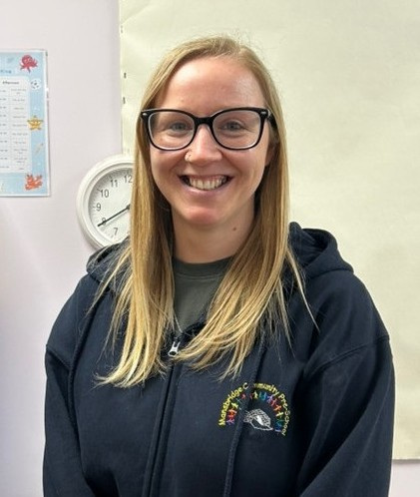 | Marie’s Crabs  Pre-School Room
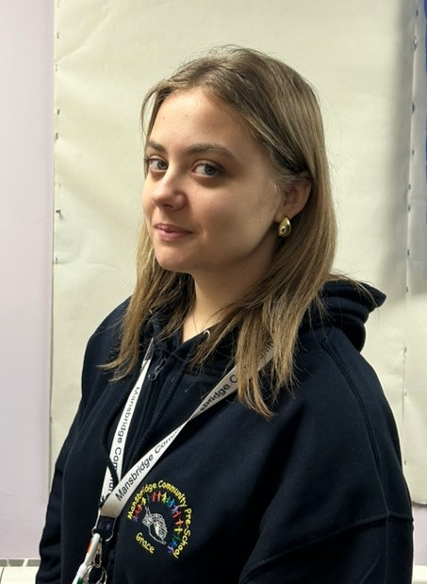 | Grace’s Jellyfish  Pre-School Room
 | Kaitlyn’s Dolphins  Pre-School Room
 Shelley King - Manager/DSL |  Jennifer King – Lead Practitioner / SENDCo |  Becky Keen – Deputy / DSL

Mansbridge Community Pre-School’s 7 Golden values
Please share these with your child, you could even use them at home.
 Walking Feet – We do not run whilst indoors, we use our walking feet.
Indoor Voices – We do not shout and scream indoors, we use our quieter indoor voices
Kind Hands – We do not hurt people or animals and we don’t damage toys and property, we use our kind hands to: shake hands, wave, hold hands, hug or help each other.
Kind Feet – We do not use our feet to hurt people or animals, we do not damage toys or property, we use our kind feet to walk, play football or running outside.
Kind Words – We do not say unkind things to people, we use our kind words to be nice to each other.
Treat our toy nicely – We don’t throw or damage toys in any way.
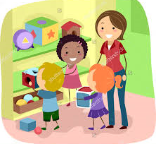 We put our toys away – When we have finished playing with our toys, we put them away before getting another toy out.

